# Creator

Проект сделан на английском языке для курса Дата Базы НИУ ВШЭ СПБ 2025

Boris Belozerov

# Description of Database:

This database contains information for streaming service. Users can find information about films, actors, awards received in various fields of the film industry, and even about soundtracks played in motion pictures. For convenience, special categories of films have been created.

* Movies

This table includes information about all movies which exist in the database.

Primary key film_id- identifier of the film

title- name of the film

year- year of the film release

genre- genre of the film

rating- rating of the film on the platform

duration_min- duration of the film in minutes

country - origin country of the film

director- director of the film

* Actor

Set provides general characteristics of actors in the films.

primary key actor_id- identifier of the actor

full_name- name and surname of the actor

age- age of the actor

gender- gender of the actor

country- origin country of the actor

* Actor_film

This set provides information about particular roles of the actor in the movies. It is needed for creating many-to-many connection

primary key actor_film_id- identifier of the actor in particular film

foreign key film_id- identifier of the film

foreign key actor_id- identifier of the actor

role_type- lead or supporting role

character- name of the played character

* Awards

Set contains information about which film won a certain nomination at various awards in given years.

primary key award_id- identifier of the award

foreign key film_id- identifier of the film

name_award- name of the award

nomination- particular nomination of the award

year- year in which particular award ceremony was hold

* Collection

This set provides names of film collections, created according to thematic division.

primary key collection_id- identifier of the collection

name_coll- name of the collection

description- short description of each collection

* Film_collection

It divides films into collections. It is needed for creating many-to-many connection

primary key first key film_collection_id- identifier of the

foreign key film_id- identifier of the film

foreign key collection_id- identifier of the collection

* Soundtrack

It stores information about all soundtracks playing in films.

primary key track_id- identifier of the track

foreign key film_id- identifier of the film

song_name- identifier of the actor

performer- singer of the group created soundtrack

duration-duration of the soundtrack

# ER Diagram

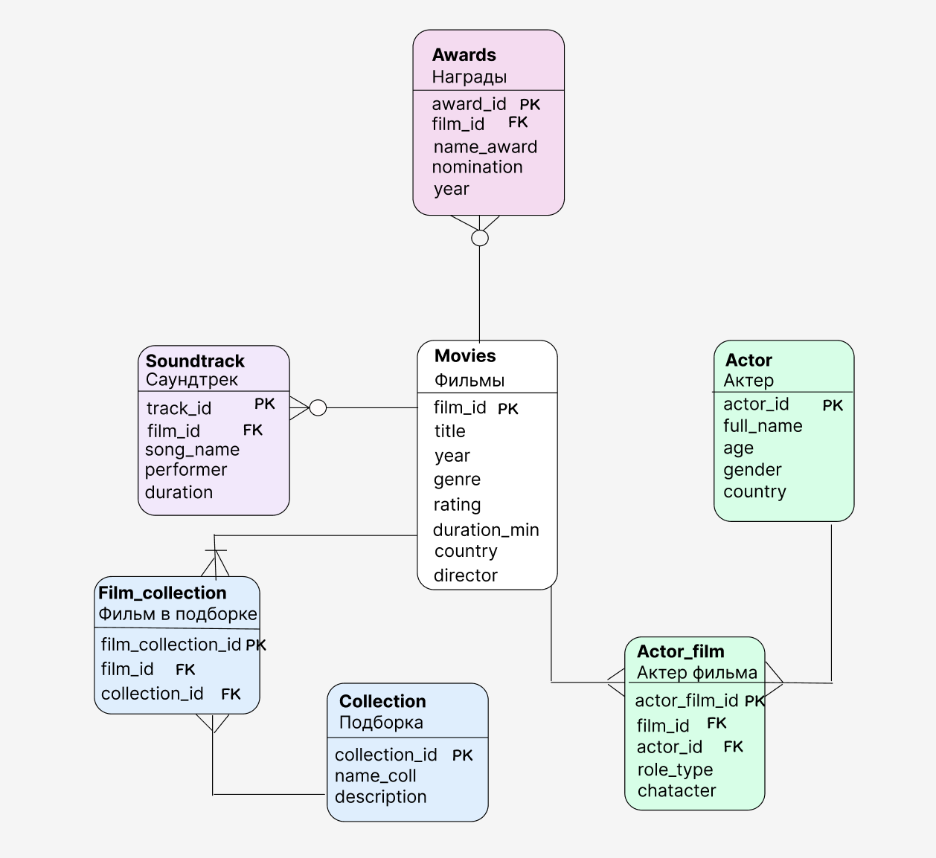

# Script for creating the table

<https://drive.google.com/file/d/1HqdeIyNXq2Rn7JTYpqe1-ZQMPQJl5O32/view?usp=sharing>

# Questions that we are answering in our script:

1.What are top 3 countries whose films won the largest quantity of the awards in 2024?

2. Who are the performers of the soundtracks of films from the collection "Romantic Comedies?

3. What role did the “Terry Mourbey” play in a film?

4.What fantasy films are on the site that last less than 120 minutes?

5.Which science fiction films were released in 2017?

6.Who played in the film “The Dark Knight”?

7.What film/films has/have the max rating on the website for films that have received the “Best Streaming Comedy Series” nomination?

8.What soundtracks are used in Canadian films released after 2010?

9.Which films on the website from the collection “Musical Masterpieces" have a rating above 4?

<https://drive.google.com/file/d/1gJTmT5n0hMkYy9zxAv7NmxcgxatV1xi6/view?usp=sharing>